**The Untitled Rogue-lite Game**

**Agenda**

I. Summary

II. Story

III. Gameplay

IV. Level Design

V. Art

VI. UI / Game Control

VII. Audio

VIII. Development Plan

**Summary**

*The Untitled Rogue-lite Game* is a top-down action rogue-lite game on mobile. The game will take players into a fantasy world to explore the map, collect loot, defeating enemies while dodging attacks.

With the intention to encourage exploration, *The Untitled Rogue-lite Game* wants to combine a typical roguelike action game with a slot-based inventory system and looting. Players will be challenged to choose what weapons, gears and items to carry with them in the next battle, and what to discard.

* Randomly generated levels and permanent death.
* Replacing virtual joystick with gyroscope & accelerometer for more intuitive movement control.
* A large variety of weapons to explore.
* Auto-aim mechanism for intuitive control.
* Dodge & roll to enable players with better control of the character.

*Minimal Viable Product*

* Combat system implemented
* Core loop completed
* One weapon
* 2 ~ 3 types of enemies

*Engine Feature Needed*

* Multiple touch input
* Gyroscope support
* Export project for Mobile
* Improved Pathfinding system (low priority)

**Story**

Setting

Narrative

**Gameplay**

Core Loop

BOSS?

YES

Player Enters a Level

NO

Exit to Next Level

Mechanics / System

i. Combat System

*ATTACK*

Attack will aim automatically. Player will only need to tap the phone screen to launch attack to the most-nearby enemy. All weapons have two attack mode: light attack and heavy attack. (reference: Soul Knight <https://www.youtube.com/watch?v=ExoeMjEq4Go&t=1s>)

Light Attack: Players tap on right side of the screen to perform light attack.

Heavy Attack: Player tap and hold on the right side of the screen to perform heavy attack. Heavy attack consumes Stamina.

*DODGE & ROLL*

Dodge and rolling will improve character’s mobility and grant IFrames (Invincibility Frames) at the startup and active animation, but not at the recovery animation. Dodge and rolling also consumes Stamina.

Players tap on the left side of the screen to perform dodge & roll.

*STAMINA*

Performing heavy attack and dodge & roll will consume Stamina. Considering Stamina as an action point. One Stamina bar will allow player to perform either one heavy attack or one dodge & roll.

Stamina will start to regenerate one second after player stop performing actions that consume Stamina. One Stamina bar will be filled after one second.

Max Stamina Bar can be upgraded from 3 bars to 6 bars max.

( reference: Curse of the Dead Gods <https://youtu.be/g2AfGcGvOfI?t=107> )

ii. Items

GEARS(Gears grant character different Upgrades)

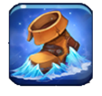**Boots of Speed**

Icon Sprite Name: icon_enhance_frosttower_tempestaura

Stackability: Not Stackable

Description: Increases the movement speed of the Hero by 30% when placed in inventory. Boots of Speed do not stack. Two boots of speed will make a Hero just as fast as one

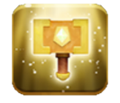**Hammer of Attack**

Icon Sprite Name: icon_enhance_crusader_blessed_hammer

Stackability: Not Stackable

Description: Increases the light attack damage of the Hero by 50% when placed in inventory. Hammer of Attack does not stack. Two Hammer of Attack will still make a Hero’s light attack deals 50% more damage.

**Helm of Valor**

Icon Sprite Name: icon_enhance_lighthouse_guardian

Stackability: Not Stackable

Description: When placed in the inventory and active, Helm of Valor will block 1 incoming attack for the Hero. After blocking the damage, Helm of Valor will become inactive, becoming active after 10 seconds.

CONSUMABLE ITEM(Usable items)

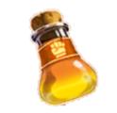**Potion**

Icon Sprite Name: icon_catalyst_main_item5_orange_02

Stackability: Stackable, 2 item / inventory slot

Description: consume to instantly regenerate 50 HP

**Bomb**

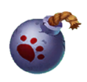 Icon Sprite Name: icon_gear_bomb_01

Stackability: Stackable, 2 item / inventory slot

Description: Place a bomb that will explode 2 seconds after placement from where the Hero is standing. Bomb explosion will deal 30 damage in a radius of 1.

iii. Slot Inventory System

Gear slots allow players to carry/equip/use items. Players swipe left/right to select the current active item.

If active item is a weapon, players tap/tap & hold to perform light attack/heavy attack.

If active item is a consumable item, players tap to use the item.

Click an item on the map to pick up. If inventory is full, replace the current active item with pickup item.

Inventory slots can be upgraded from 2 to 4 max slots.

SHOP

Characters will be able to spend their money in a shop, which has a similar layout as the reference picture has shown.

Character buys an item by simply click on the item to buy, and then item will appear in the inventory slot and money will be deduct accordingly. Character will not be able to purchase an item if the inventory slot is already full.

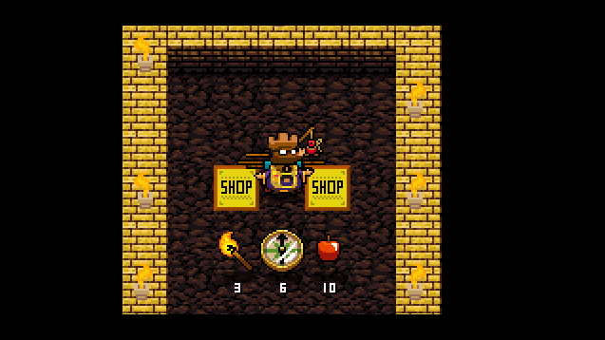

Character Progression

MONEY

By slaying enemies, character will be able to receive certain amount of the gold. Gold can be used to purchase items that empower the character in a shop.

Enemies

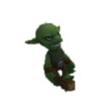**Goblin**

Attack Mode: Melee

Max Health: 8

Move Speed: 2

Damage Dealt: 15

Search Range: 5

Reset Radius: 2

Gold Drop: 3 ~ 5

Location: Goblin Forest

Move towards and follow the player once player moved in the search range.

Attack when move close enough to the player. Cannot move while attacking.

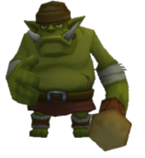**Hobgoblin**

Attack Mode: Melee

Max Health: 45

Move Speed: 1

Damage Dealt: 30

Search Range: 5

Reset Radius: 2

Gold Drop: 5 ~ 8

Location: Goblin Forest

Move towards and follow the player once player moved in the search range.

Attack when move close enough to the player.

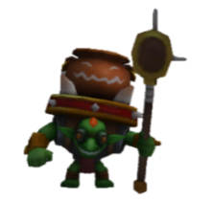**Goblin Chief**

Attack Mode: Ranged

Max Health: 20

Move Speed: 1

Damage Dealt: 15

Search Range: 6

Reset Radius: 3

Gold Drop: 3 ~ 5

Location: Goblin Forest

Move towards the player if player is out of attack range; move away from the player if player is closer than the attack range.

Attack by firing one projectile three times consecutively (one volley of shots). Attack will have 5 seconds cooldown.

Cannot move while attacking. Move towards or away from the player after finish one volley of shots.

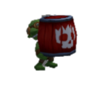**Goblin Sapper**

Attack Mode: Ability

Max Health: 5

Move Speed: 1.5

Damage Dealt: 0

Search Range: 5

Reset Radius: 2

Gold Drop: 0

Location: Goblin Forest

Move towards and follow the player once player moved in the search range.

Once in attack range, initialize an Explosion ability that explodes half of a second after initialization.

The explosion will deal 50 damage to everything in a radius of 1, centered around Goblin Sapper.

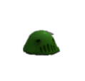**Ooze**

Attack Mode: Melee

Max Health: 5

Move Speed: 1.5

Damage Dealt: 0

Search Range: 5

Reset Radius: 2

Gold Drop: 1

Location: Goblin Forest

Move towards and follow the player once player moved in the search range.

When it attacks with player character, slow player character’s movement down by 40% for 3 seconds.

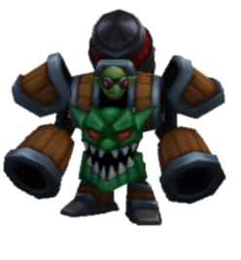**BOSS Goblin Miner**

Attack Mode: Melee/Ranged

Max Health: 300

Move Speed: 1

Search Range: 5

Reset Radius: 2

Gold Drop: 50 ~ 60

Location: Goblin Forest

BOSS will move randomly on the map and stop to cast attack abilities.

Attack Pattern

1. Rocket Barrage

Using boss_goblin_miner_ground’s “attack” animation to launch 4 ~ 5 rockets into the sky, falling near the players one by one, dealt an area damage of 30 in a radius of 1.

BOSS will be casting this ability for 3 seconds before rockets start falling. BOSS cannot move during the casting.

2. Leap Attack

Similar to player character’s dodging ability, BOSS will jump towards the last position of the player when BOSS start leaping.

Upon landing, the BOSS will impact in a radius of 1.5 centered around the BOSS, dealing 50 damage.

3. Drill Missile

Using boss_goblin_miner_ground’s “action1” animation to launch Drill Missile (model boss_goblin_minder_drill_missile) in a cone shape towards the last position of the player when finishing casting ability. Drill Missile will last 3 seconds deal 25 per seconds while players standing in that range.

BOSS will be casting this ability for 1.5 seconds before shooting. BOSS will auto aim and rotate towards the player while standing still during the casting.

4. Summon Goblins

Using boss_goblin_miner_ground’s “action 2” animation to summon 5 Goblins (same as the Goblin enemy)

BOSS will cast this ability instantly.

**Level Design**

We are closely following how has *Binding of Isaac* procedurally generated its level with both hand-crafted templates and randomly generated layout.

Each Dungeon is made of THREE levels, with difficulty increases as players progress. At the end of the third level, in other words, at the end of the Dungeon, one BOSS will be spawn in the EXIT ROOM on the third level.

Each room template will be categorized by its functionality and the orientation of its exit(s). Each room template will store the data regarding its functionalities and exit orientations.

Functionality:

1. Common Room: rooms that will spawn enemies, the most common room type.

2. Secret Room: rooms that will only have one exit. They often mark the end of a pathway.

3. Merchant Room: rooms that allow player to buy items.

Each room will have, at most, 4 exits. Exits will appear on either / both TOP, BOTTOM, LEFT, RIGHT side of the room. (For example, CR_TBR_00 represent the Common Room #00 which has exits on TOP, BOTTOM and RIGHT)

The room generation follow the guide below:

1. Randomly select a Common Room and place down as the starting room. (starting room will spawn Trap Door / Level Exit and spawn no enemies.)

2. Depending on the random room template selected as the starting room, algorithm randomly picks an existing exit orientation to place the next room. (For example, if the starting room is a CR_TBR, the next room will be placed either to the TOP, BOTTOM, or RIGHT of the starting room)

3. Once the algorithm determines the next room’s spawn point, first check whether there is already an existing room on that spawn point. If yes, jump to that room and start from STEP 2 again.

If no, check the 4-side of the spawning point, whether there is an existing room, or existing exit pointing towards the room spawn point.

4. Check whether the positions of the existing rooms around the spawn point match the exits pointing towards the spawn point. (For example, if there is an existing room to the left of the spawn point, there should also be an existing exit on the left of the spawn point, pointing towards the spawning point.)

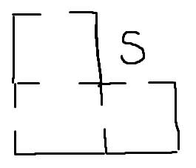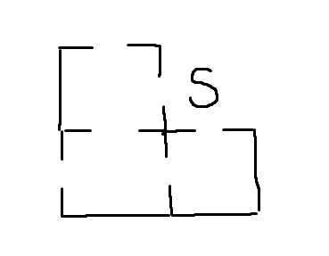If yes, randomly select a room template that at least has the exit orientations that match the existing exits point towards it. (For example, see the image to the right, if “S” is the room spawn point, the algorithm should randomly pick among room templates that have at least a LEFT exit and a BOTTOM exit, meaning it can pick a template who has exits orientations of either BL (BOTTOM, LEFT), or TBL, or BLR, or TBLR.)

If existing rooms and existing exits around the spawn point do not match up (consider the situation shown in the image on the right, there is a room existing to the left of the spawn point but no exit pointing towards the spawn point), locate the room without an exit pointing towards the spawn point, change that room into one that contains an exit point towards the spawn point (in this case, change the TB room to the left of the spawn point into a TBR room template).

After making sure all existing rooms around the spawn point has an exit pointing towards the spawn point, place a room template that at least has the exit orientations that match the existing exits point towards it.

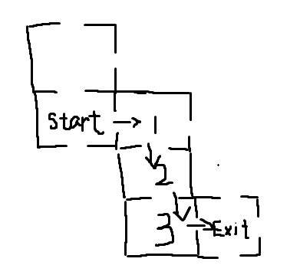5. After placed down another room, repeat STEP 2 until the shortest to reach one of the rooms from the starting room is exactly 4 rooms away. (See image to the right) Then mark that room as the Exit room and connect all the open exits with secret rooms.

Mob Spawning

Each room template will have its own specific Enemy Spawn Point.

Then depending on the current level of the dungeon the player is in, the room will select a difficulty level first, then randomly select a set of enemies to spawn. (reminder: each dungeon will contain the maximum of three levels)

After selecting a set of enemies to spawn, spawning the enemies in that set randomly on the Enemy Spawn Point specifically to that room template, till all enemies in the sets are spawned. (Each spawn point only spawn one enemy)

Dungeon level 1: (80%) spawn a set from LEVEL 1 ENEMY SETS

(20%) spawn a set from LEVEL 2 ENEMY SETS

Dungeon level 2: (10%) spawn a set from LEVEL 1 ENEMY SETS

(80%) spawn a set from LEVEL 2 ENEMY SETS

(10%) spawn a set from LEVEL 3 ENEMY SETS

Dungeon level 3: (10%) spawn a set from LEVEL 1 ENEMY SETS

(40%) spawn a set from LEVEL 2 ENEMY SETS

(50%) spawn a set from LEVEL 3 ENEMY SETS

*(enemy sets in different are noted in the Mod -> RoomMod -> Trigger.lua)*

**Art**

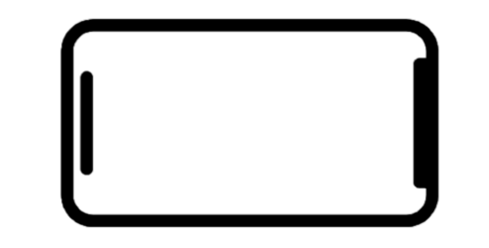**UI / Game Control**

Control Scheme



Gyroscope for Character Movement

Dodge

Attack

Action

Use Item

**Audio**

**Development Plan**